# Diabetes Classification Results using GradientBoosting

## Classification Report:

precision recall f1-score support  
  
 0 0.83 0.74 0.78 149  
 1 0.77 0.85 0.81 151  
  
 accuracy 0.79 300  
 macro avg 0.80 0.79 0.79 300  
weighted avg 0.80 0.79 0.79 300

## ROC AUC Score:

ROC AUC Score (GradientBoosting): 0.849148851060047

## ROC Curve:

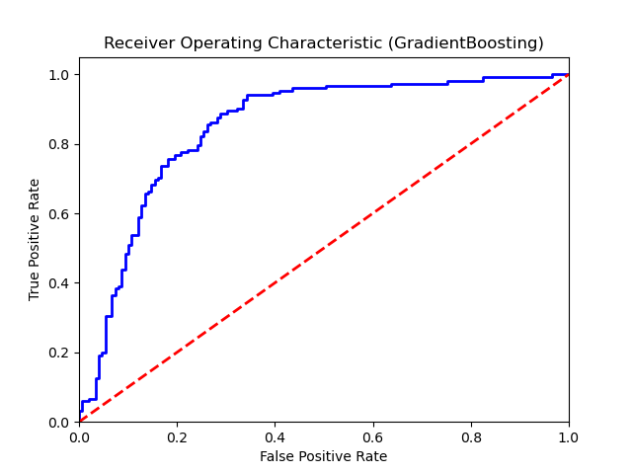

## Confusion Matrix:

True Negatives: 110

False Positives: 39

False Negatives: 23

True Positives: 128

## Confusion Matrix Plot:

